

Dr. Sandra, Fox inc.

2020-07-24

Dr. Fox

95262 Leon Skyway Apt. 968, Dianeville, ME 21631

Phone: 4947949955

Fax: 7722986504

**Re:** Cynthia, Stokes

**PHN:** 7742181678

**Birthdate:** 05-Feb-1967

**Address:** 3790 John Rue Apt. 475, Patrickmouth, ND 42387

**Patient number:** 1120565492

To Whom It May Concern:

This is a medical letter to state the above patient is pregnant with expected delivery date of 29-May-2025. Hoping this information is satisfactory for your requirements.

Thank you.

Sincerely,

Dr. Sandra, Fox

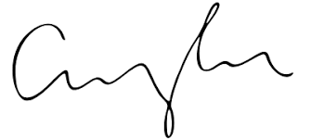

FRCS© NCMP

Clinical Assistant Professor, UBC

Department of Obstetrics and Gynecology SMH